Лабораторна робота №13
Тема: Розробка веб-сайту
Мета: знайомство з PDO для роботи з базами даних у мові PHP.

Хід роботи
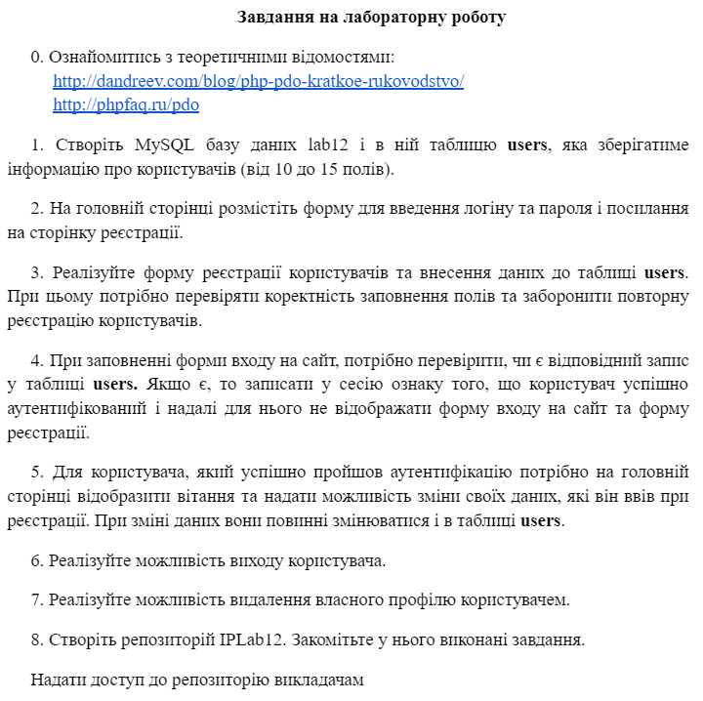
Лістинг програми:
<?php
session_start();
require_once('config.php');
if(isset($_POST['submit']))
{
if(isset($_POST['email'],$_POST['password']) && !empty($_POST['email']) && !empty($_POST['password']))
{
$email = $_POST['email'];
$password = $_POST['password'];
echo $email;
echo $password;
if(filter_var($email, FILTER_VALIDATE_EMAIL))
{
$sql = "select * from members where email = :email ";
$handle = $pdo -> prepare($sql);
$params = ['email'=>$email];
$handle->execute($params);
if($handle->rowCount() != 0)
{
$getRow = $handle->fetch(PDO::FETCH_ASSOC);
if($password == $getRow['password'])
{
$_SESSION = $getRow;
header('location:dashboard.php');
exit();
}
else
{
$errors[] = "Wrong Email or Password1";
}
}
else
{
$errors[] = "Wrong Email or Password2";
}
}
else
{
$errors[] = "Email address is not valid";
}
}
else
{
$errors[] = "Email and Password are required";
}
}
?>
<!DOCTYPE html>
<html>
<head>
<title>lab13</title>
<link href="https://cdn.jsdelivr.net/npm/bootstrap@5.1.3/dist/css/bootstrap.min.css" rel="stylesheet" integrity="sha384-1BmE4kWBq78iYhFldvKuhfTAU6auU8tT94WrHftjDbrCEXSU1oBoqyl2QvZ6jIW3" crossorigin="anonymous">
</head>
<body>
<main>
<div class="container">
<legend>Log in</legend>
<?php
if(isset($errors) && count($errors) > 0)
{
foreach($errors as $error_msg)
{
echo '<div class="alert alert-danger">'.$error_msg.'</div>';
}
}
?>
<form method="POST" action="<?php echo $_SERVER['PHP_SELF'];?>">
<div class="mb-3">
<label for="exampleInputEmail1" class="form-label">Email address</label>
<input type="email" name="email" class="form-control" id="exampleInputEmail1" aria-describedby="emailHelp">
<div id="emailHelp" class="form-text">We'll never share your email with anyone else.</div>
</div>
<div class="mb-3">
<label for="exampleInputPassword1" class="form-label">Password</label>
<input type="password" name="password" class="form-control" id="exampleInputPassword1">
</div>
<div class="mb-3 form-check">
<input type="checkbox" class="form-check-input" id="exampleCheck1">
<label class="form-check-label" for="exampleCheck1">Check me out</label>
</div>
<button type="submit" name="submit" class="btn btn-primary">Submit</button>
<a href="register.php" class="btn btn-primary">Register</a>
</form>
</div>
</main>
<script src="https://cdn.jsdelivr.net/npm/bootstrap@5.1.3/dist/js/bootstrap.bundle.min.js" integrity="sha384-ka7Sk0Gln4gmtz2MlQnikT1wXgYsOg+OMhuP+IlRH9sENBO0LRn5q+8nbTov4+1p" crossorigin="anonymous"></script>
<script src="https://cdn.jsdelivr.net/npm/@popperjs/core@2.10.2/dist/umd/popper.min.js" integrity="sha384-7+zCNj/IqJ95wo16oMtfsKbZ9ccEh31eOz1HGyDuCQ6wgnyJNSYdrPa03rtR1zdB" crossorigin="anonymous"></script>
<script src="https://cdn.jsdelivr.net/npm/bootstrap@5.1.3/dist/js/bootstrap.min.js" integrity="sha384-QJHtvGhmr9XOIpI6YVutG+2QOK9T+ZnN4kzFN1RtK3zEFEIsxhlmWl5/YESvpZ13" crossorigin="anonymous"></script>
</body>
</html>

<?php
session_start();
if(isset($_SESSION)){
session_destroy();
header('location:log_in_form.php');
exit();
}
?>

<?php
session_start();
require_once('config.php');
if(isset($_POST['submit']))
{
if(isset($_POST['first_name'],$_POST['last_name'],$_POST['email'],$_POST['password']) && !empty($_POST['first_name']) && !empty($_POST['last_name']) && !empty($_POST['email']) && !empty($_POST['password']))
{
$firstName = $_POST['first_name'];
$lastName = $_POST['last_name'];
$email = $_POST['email'];
$password = $_POST['password'];
$date = date('Y-m-d H:i:s');
if(filter_var($email, FILTER_VALIDATE_EMAIL))
{
$sql = 'select * from members where email = :email';
$stmt = $pdo->prepare($sql);
$p = ['email'=>$email];
$stmt->execute($p);
if($stmt->rowCount() == 0)
{
$sql = "insert into members (first_name, last_name, email, `password`, created_at,updated_at) values(:fname,:lname,:email,:pass,:created_at,:updated_at)";
try{
$handle = $pdo->prepare($sql);
$params = [
':fname'=>$firstName,
':lname'=>$lastName,
':email'=>$email,
':pass'=>$password,
':created_at'=>$date,
':updated_at'=>$date
];
$handle->execute($params);
$success = 'User has been created successfully';
}
catch(PDOException $e){
$errors[] = $e->getMessage();
}
}
else
{
$valFirstName = $firstName;
$valLastName = $lastName;
$valEmail = '';
$valPassword = $password;
$errors[] = 'Email address already registered';
}
}
else
{
$errors[] = "Email address is not valid";
}
}
else
{
if(!isset($_POST['first_name']) || empty($_POST['first_name']))
{
$errors[] = 'First name is required';
}
else
{
$valFirstName = $_POST['first_name'];
}
if(!isset($_POST['last_name']) || empty($_POST['last_name']))
{
$errors[] = 'Last name is required';
}
else
{
$valLastName = $_POST['last_name'];
}
if(!isset($_POST['email']) || empty($_POST['email']))
{
$errors[] = 'Email is required';
}
else
{
$valEmail = $_POST['email'];
}
if(!isset($_POST['password']) || empty($_POST['password']))
{
$errors[] = 'Password is required';
}
else
{
$valPassword = $_POST['password'];
}
}
}
?>
<!doctype html>
<html>
<head>
<link rel="stylesheet" href="https://stackpath.bootstrapcdn.com/bootstrap/4.1.3/css/bootstrap.min.css" integrity="sha384-MCw98/SFnGE8fJT3GXwEOngsV7Zt27NXFoaoApmYm81iuXoPkFOJwJ8ERdknLPMO" crossorigin="anonymous">
</head>
<body>
<div class="container h-100">
<div class="row h-100 mt-5 justify-content-center align-items-center">
<div class="col-md-5 mt-3 pt-2 pb-5 align-self-center border bg-light">
<h1 class="mx-auto w-25" >Register</h1>
<?php
if(isset($errors) && count($errors) > 0)
{
foreach($errors as $error_msg)
{
echo '<div class="alert alert-danger">'.$error_msg.'</div>';
}
}
if(isset($success))
{
echo '<div class="alert alert-success">'.$success.'</div>';
}
?>
<form method="POST" action="<?php echo $_SERVER['PHP_SELF'];?>">
<div class="form-group">
<label for="email">First Name:</label>
<input type="text" name="first_name" placeholder="Enter First Name" class="form-control" value="<?php echo (isset($valFirstName) ? $valFirstName : '')?>">
</div>
<div class="form-group">
<label for="email">Last Name:</label>
<input type="text" name="last_name" placeholder="Enter Last Name" class="form-control" value="<?php echo (isset($valLastName) ? $valLastName : '')?>">
</div>
<div class="form-group">
<label for="email">Email:</label>
<input type="text" name="email" placeholder="Enter Email" class="form-control" value="<?php echo (isset($valEmail) ? $valEmail : '')?>">
</div>
<div class="form-group">
<label for="email">Password:</label>
<input type="password" name="password" placeholder="Enter Password" class="form-control" value="<?php echo (isset($valPassword) ? $valPassword : '')?>">
</div>
<button type="submit" name="submit" class="btn btn-primary">Submit</button>
<p class="pt-2"> Back to <a href="log_in_form.php">Login</a></p>
</form>
</div>
</div>
</div>
</body>
</html>

<?php
session_start();
require_once('config.php');
if(isset($_POST['submit']))
{
if(isset($_POST['first_name'],$_POST['last_name'],$_POST['email'],$_POST['password']) && !empty($_POST['first_name']) && !empty($_POST['last_name']) && !empty($_POST['email']) && !empty($_POST['password'])) {
$first_name = $_POST['first_name'];
$last_name = $_POST['last_name'];
$email = $_POST['email'];
$password = $_POST['password'];
$updated_at = date('Y-m-d H:i:s');
if (filter_var($email, FILTER_VALIDATE_EMAIL)) {
$sql = "select * from members where email = :email ";
$handle = $pdo->prepare($sql);
$params = ['email' => $email];
$handle->execute($params);
if ($handle->rowCount() != 0) {
$getRow = $handle->fetch(PDO::FETCH_ASSOC);
foreach ($getRow as $item){
echo $item;
echo "\n";
}
foreach ($_SESSION as $item){
echo $item;
echo "\n";
}
echo $getRow;
if ($first_name != $getRow['first_name']) {
$sql_pass2 = "UPDATE members SET first_name=:first_name, updated_at=:updated_at WHERE id={$getRow["id"]}";
$ch2 = $pdo -> prepare($sql_pass2);
$ch2 -> execute(["first_name"=> $first_name,
"updated_at"=> $updated_at]);
$_SESSION = $getRow;
header('location:log_in_form.php');
exit();
} else {
$errors[] = "Error2";
}
if ($password != $getRow['password']) {
$sql_pass1 = "UPDATE members SET password={$password}, updated_at=:updated_at WHERE id={$getRow["id"]}";
$ch1 = $pdo -> prepare($sql_pass1);
$ch1 -> execute(["updated_at"=> $updated_at]);
$_SESSION = $getRow;
header('location:log_in_form.php');
exit();
} else {
$errors[] = "Error1";
}
if ($last_name != $getRow['last_name']) {
$sql_pass3 = "UPDATE members SET last_name=:last_name, updated_at=:updated_at WHERE id = {$getRow["id"]}";
$ch3 = $pdo -> prepare($sql_pass3);
$ch3 -> execute(["last_name"=> $last_name, "updated_at"=> $updated_at]);
$_SESSION = $getRow['last_name'];
header('location:log_in_form.php');
exit();
} else {
$errors[] = "Error3";
}
if ($email != $getRow['email']) {
$sql_pass4 = "UPDATE members SET email=:email, updated_at=:updated_at WHERE id={$getRow["id"]}";
$ch4 = $pdo -> prepare($sql_pass4);
$ch4 -> execute(["email"=> $email, "updated_at"=> $updated_at]);
$_SESSION = $getRow;
header('location:log_in_form.php');
exit();
} else {
$errors[] = "Error4";
}
}
header('location:log_in_form.php');
exit();
}
}
}
?>
<!doctype html>
<html>
<head>
<link rel="stylesheet" href="https://stackpath.bootstrapcdn.com/bootstrap/4.1.3/css/bootstrap.min.css" integrity="sha384-MCw98/SFnGE8fJT3GXwEOngsV7Zt27NXFoaoApmYm81iuXoPkFOJwJ8ERdknLPMO" crossorigin="anonymous">
</head>
<body>
<div class="container h-100">
<div class="row h-100 mt-5 justify-content-center align-items-center">
<div class="col-md-5 mt-3 pt-2 pb-5 align-self-center border bg-light">
<h1 class="mx-auto w-25" >Changes</h1>
<?php
if(isset($errors) && count($errors) > 0)
{
foreach($errors as $error_msg)
{
echo '<div class="alert alert-danger">'.$error_msg.'</div>';
}
}
if(isset($success))
{
echo '<div class="alert alert-success">'.$success.'</div>';
}
?>
<form method="POST" action="<?php echo $_SERVER['PHP_SELF'];?>">
<div class="form-group">
<label for="email">First Name:</label>
<input type="text" name="first_name" placeholder="Enter First Name" class="form-control" value="<?php echo $_SESSION["first_name"]; ?>">
</div>
<div class="form-group">
<label for="email">Last Name:</label>
<input type="text" name="last_name" placeholder="Enter Last Name" class="form-control" value="<?php echo $_SESSION["last_name"]; ?>">
</div>
<div class="form-group">
<label for="email">Email:</label>
<input type="text" name="email" placeholder="Enter Email" class="form-control" value="<?php echo $_SESSION["email"]; ?>">
</div>
<div class="form-group">
<label for="email">Password:</label>
<input type="password" name="password" placeholder="Enter Password" class="form-control" value="<?php echo $_SESSION["password"]; ?>">
</div>
<button type="submit" name="submit" class="btn btn-primary">Submit</button>
<p class="pt-2"> Back to <a href="log_in_form.php">Login</a></p>
</form>
</div>
</div>
</div>
</body>
</html>

<?php
session_start();
if(!$_SESSION['id']){
header('location:log_in_form.php');
}
?>
<h1>Welcome <?php echo ucfirst($_SESSION['first_name']); ?></h1>
<a href="logout.php?logout=true">Logout</a>
<a href="change.php?logout=true">Change</a>
<a href="delete.php?logout=true">DELETE</a>

<?php
session_start();
require_once('config.php');
$id = $_SESSION["id"];
$sql = "DELETE FROM members WHERE id ={$id}";
$stmt = $pdo->prepare($sql);
$stmt->execute();
session_destroy();
header('location:log_in_form.php');
?>

<?php
$dsn = 'mysql:dbname=lab13;host=localhost';
$user = 'root';
$password = '';
try
{
$pdo = new PDO($dsn,$user,$password);
$pdo->setAttribute(PDO::ATTR_ERRMODE, PDO::ERRMODE_EXCEPTION);
}
catch(PDOException $e)
{
echo "PDO error".$e->getMessage();
die();
}
?>
Результат роботи програми:

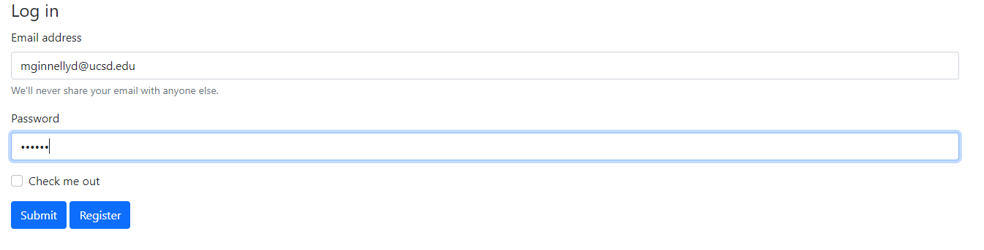

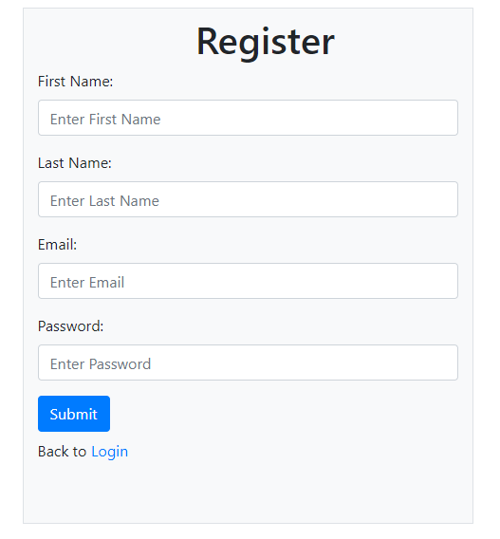

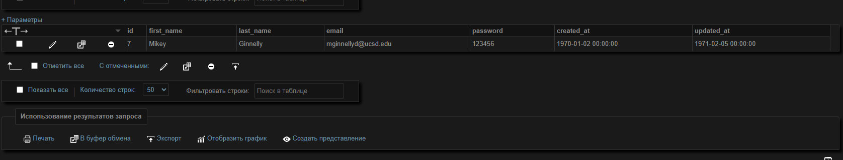

Висновок: У лабораторній роботі я працював з PDO у мові програмування PHP. Розробив власну БД. На сайті реалізував систему реєстрації та керування акаунту.
Навчився працювати з запитами до БД. Також закріпив знання що до bootstrap.

